[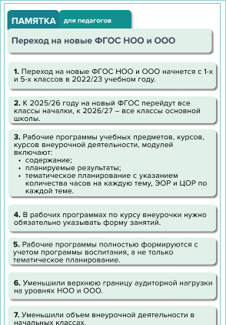](https://vip.1zavuch.ru/?utm_medium=refer&utm_source=www.menobr.ru&utm_term=62732&utm_content=news&utm_campaign=red_block_content_button)